Terraform - 06
1). Watch the Terraform-06 video.
2). Execute the script shown in the video.

Terraform import ⇒ is used to bring existing real-world infrastructure into Terraform state.
terraform import aws_instance.manual <instance id>

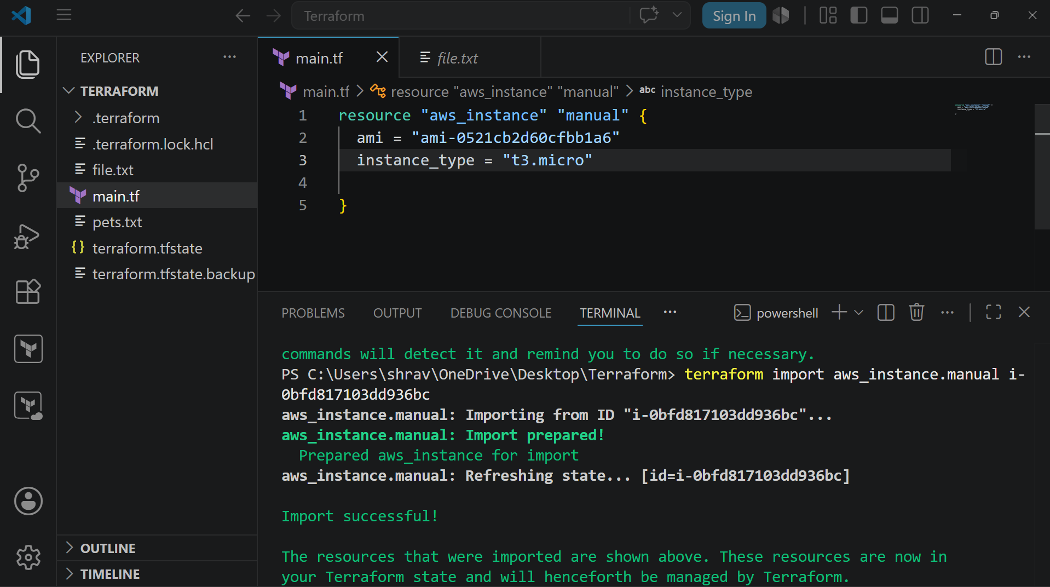

Terraform Module
A Terraform module is a reusable package of Terraform code that groups resources together and can be used multiple times.
Lets create a directory first called aws_instance
In directory lets create two files
- main.tf
- variables.tf
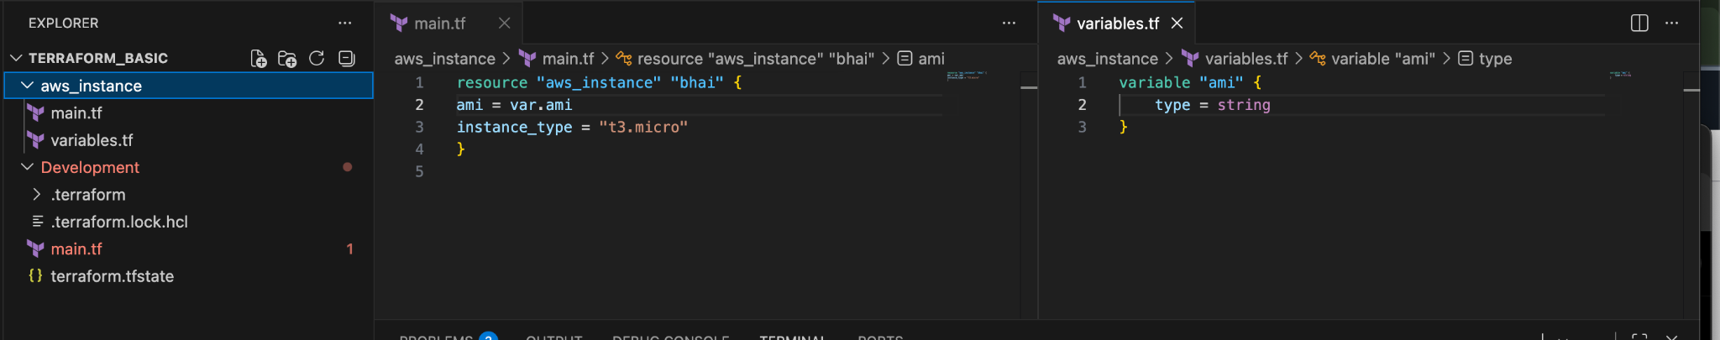
Now lets create another directory called development
In this lets create another main.tf
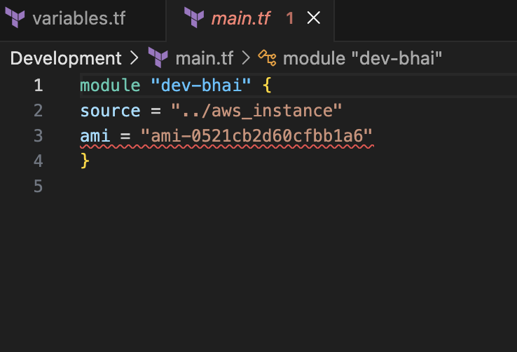
lets do terraform init
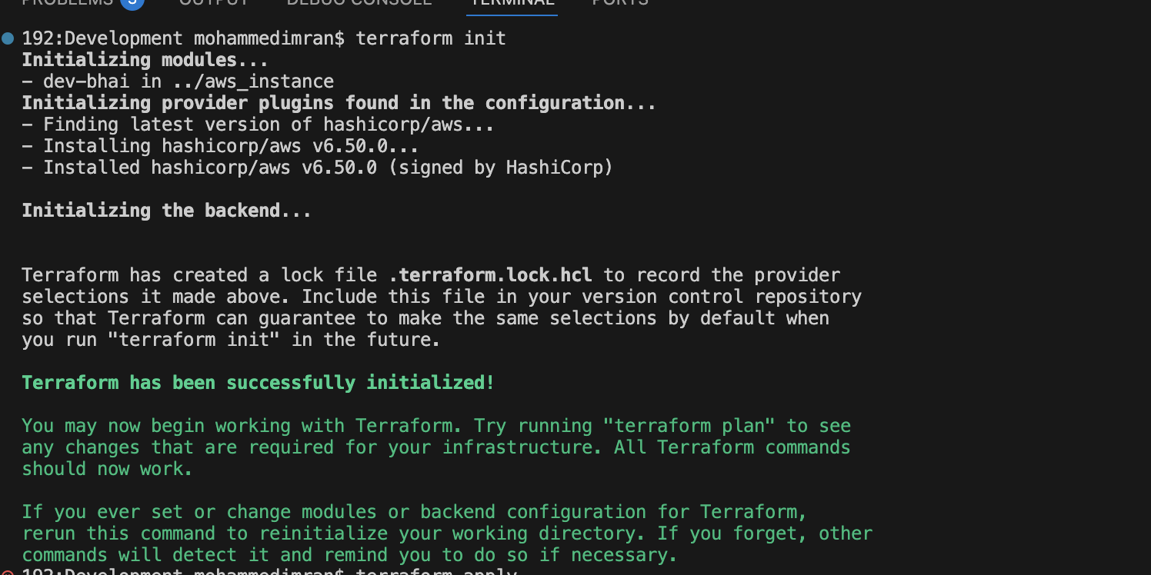
Now lets execute terraform apply
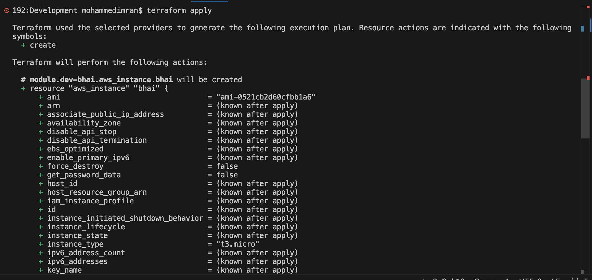
Now we can see terraform.tf file has been created in Development Directory
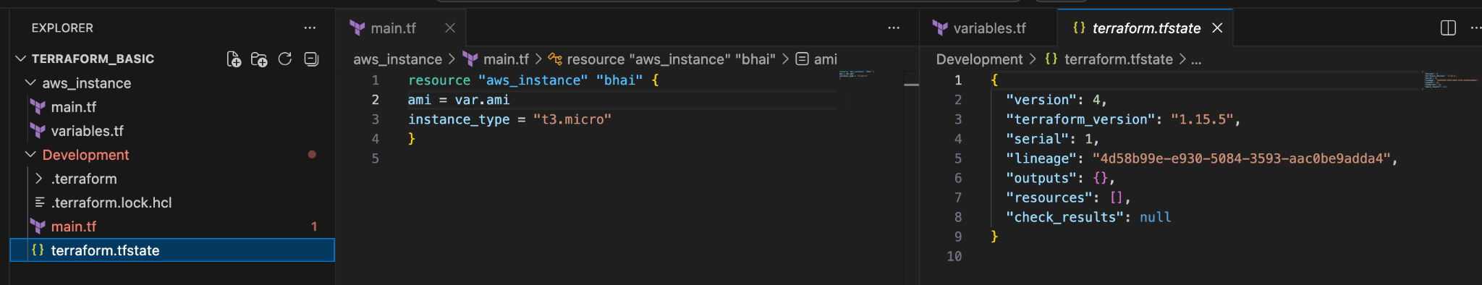

Terraform Workspace
Workspace can be used if we have multiple projects/environments using the same configuration.
Lets create main.tf and variables.tf files
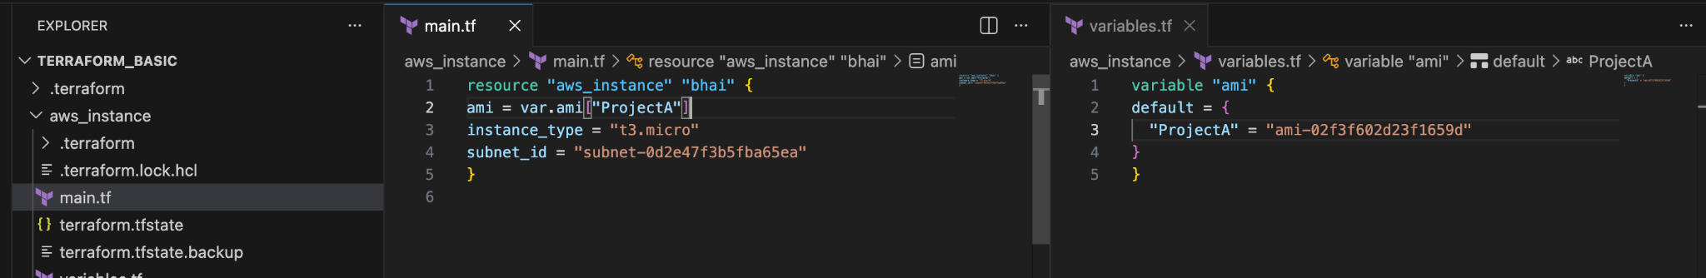
For creating workspace
terraform workspace new projectA ⇒ for creating a new workspace
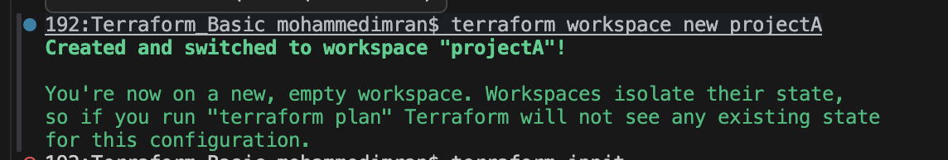

We can see the new workspace created in terraform.tfstate.d
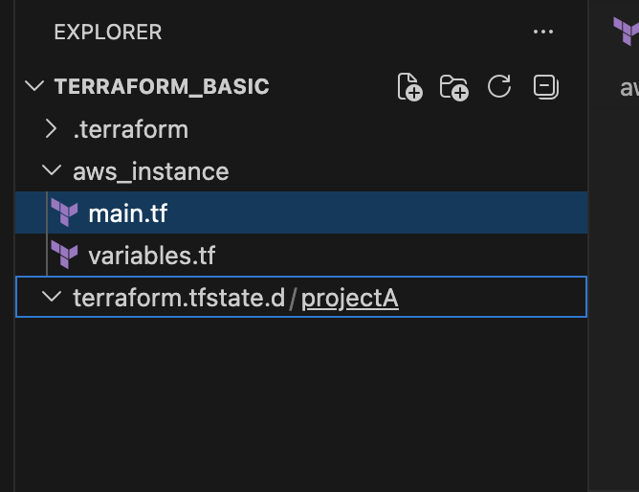
terraform workspace list ⇒ for getting list of workspace
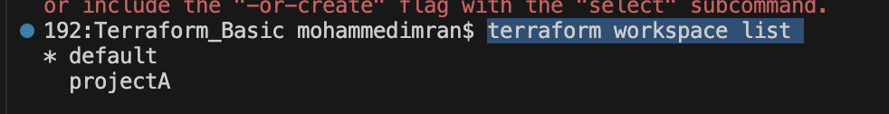
terraform workspace selecr projectA ⇒to swtich to specific workspace

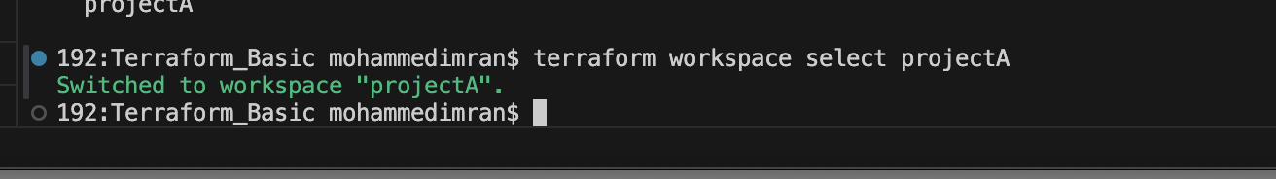

Lets check if the folder called ProjectA
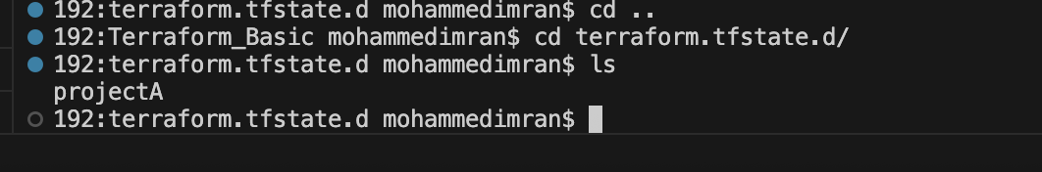

Lets do terraform init now
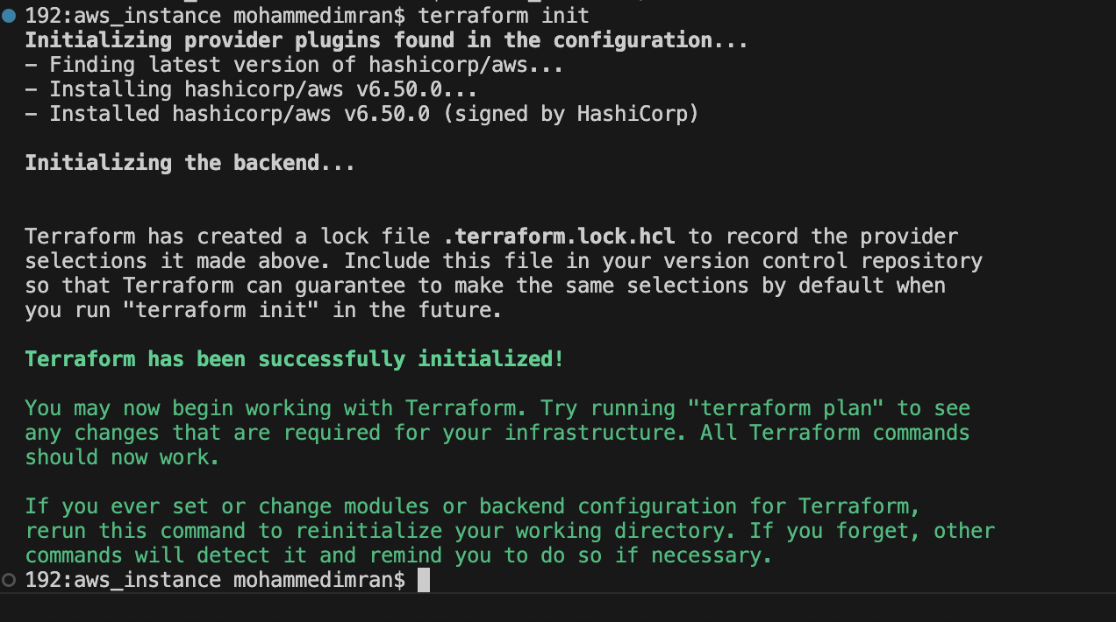
terraform apply
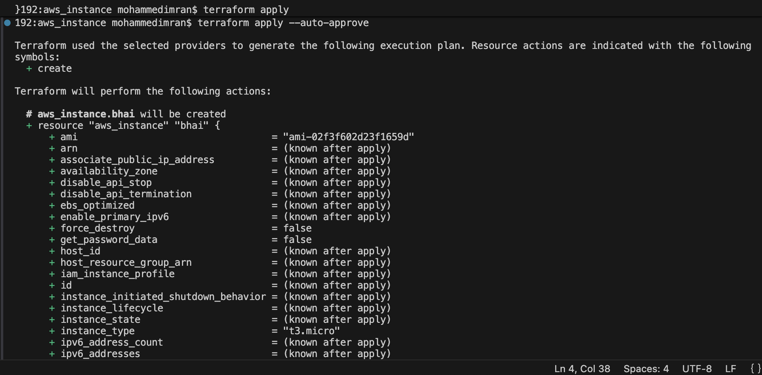
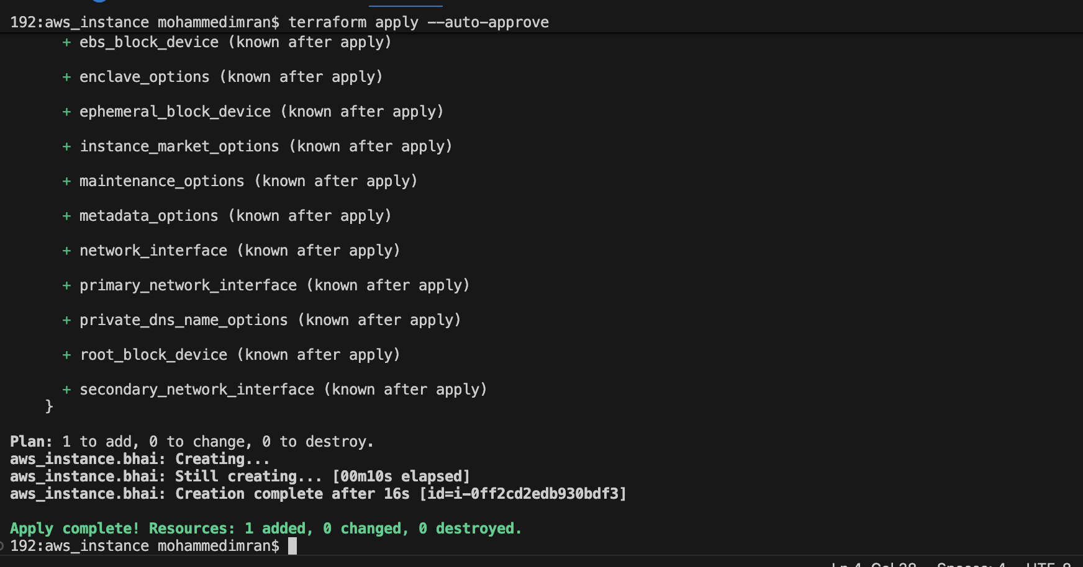
Lets check in aws ec2 if the instance has been created or not

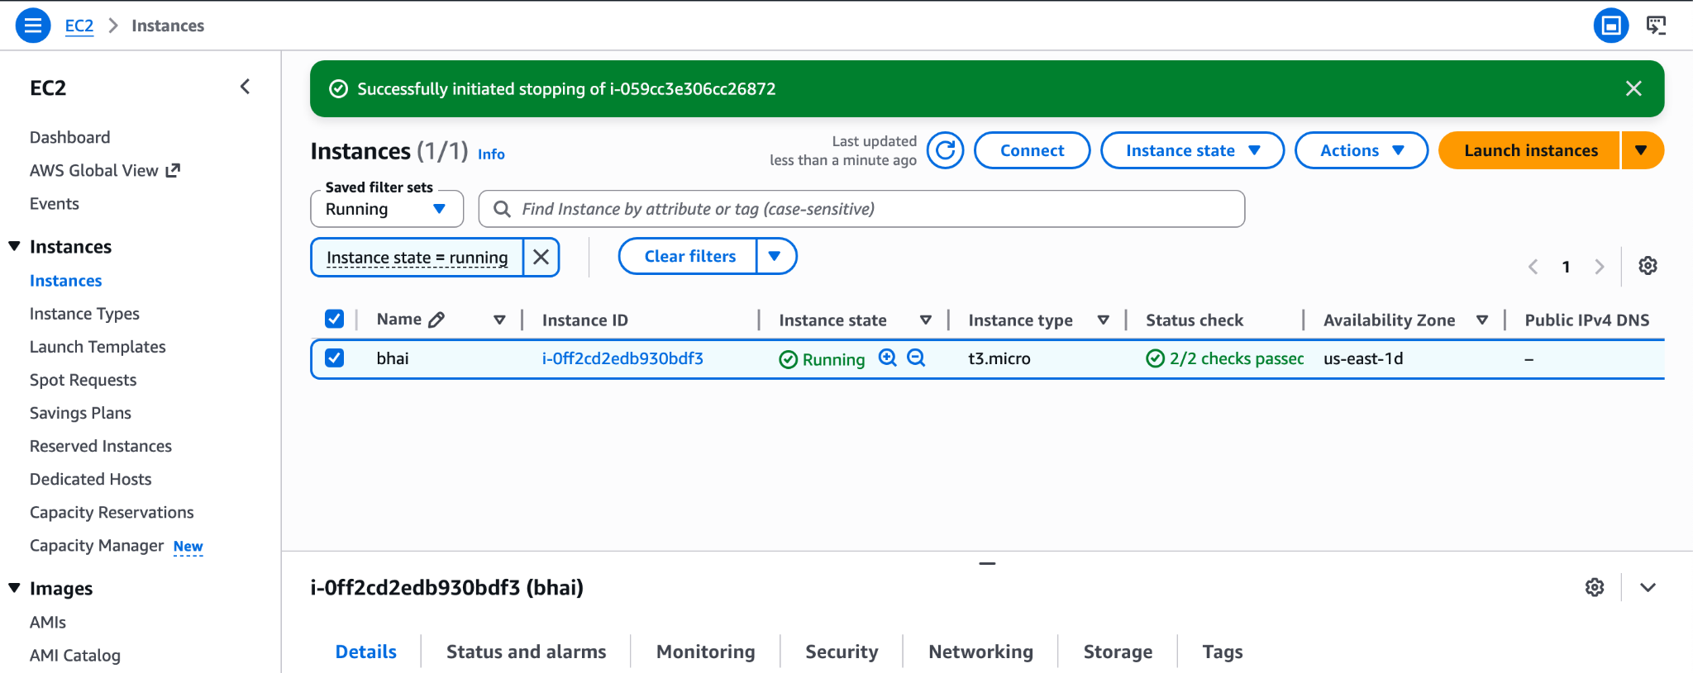

3). Provision EC2, S3, and VPC using Terraform modules.
So let's create a directory called aws_instance →main.tf
Lets create a sub directory called Modules → inside modules create 3 folders each and 3 files inside each folder with names VPC→main.tf, S3→main.tf, ec2→main.tf
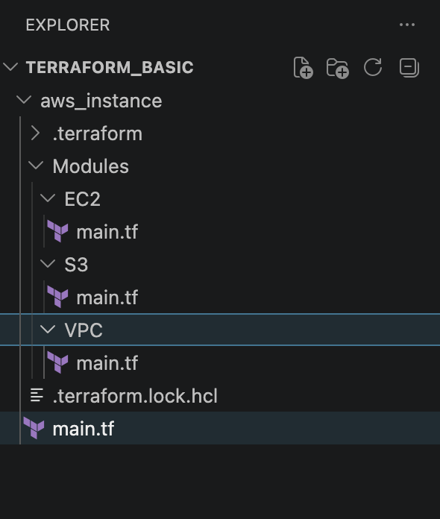

aws_instance →main.tf
provider “aws”{
Region = “us-east-1”
}
module "vpc" {
source = "./modules/vpc"
}

module "s3" {
source = "./modules/s3"
}

module "ec2" {
source = "./modules/ec2"
}

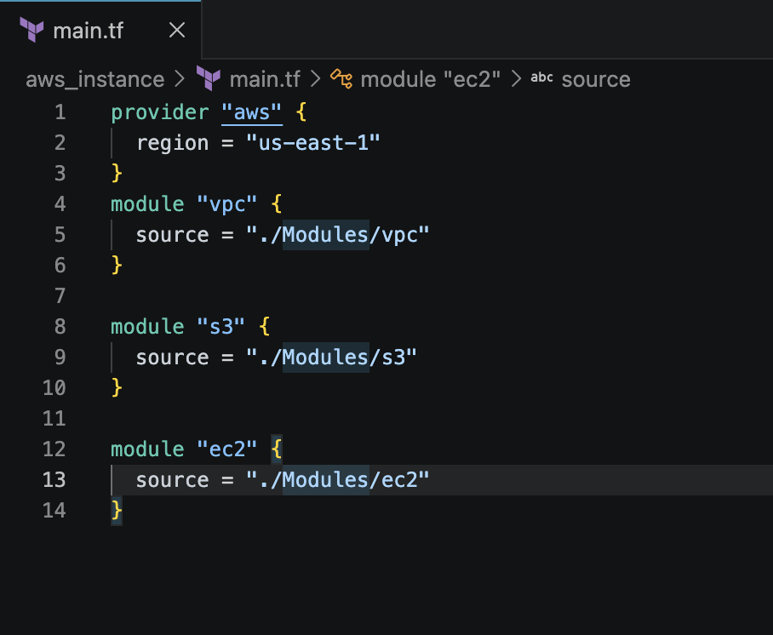
Modules
VPC →main.tf
resource "aws_vpc" "my_vpc" {

cidr_block = "10.0.0.0/16"

tags = {
Name = "terraform-vpc"
}
}

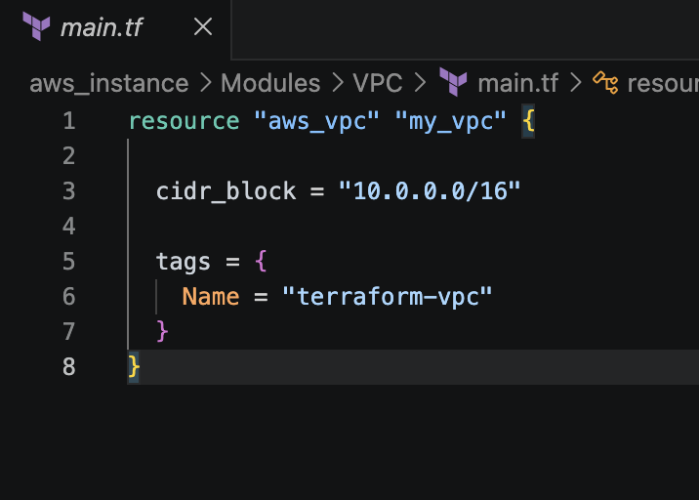
S3 →main.tf
resource "aws_s3_bucket" "my_bucket" {

bucket = "javeed-terraform-module-demo-12345"

tags = {
Name = "terraform-s3"
}
}

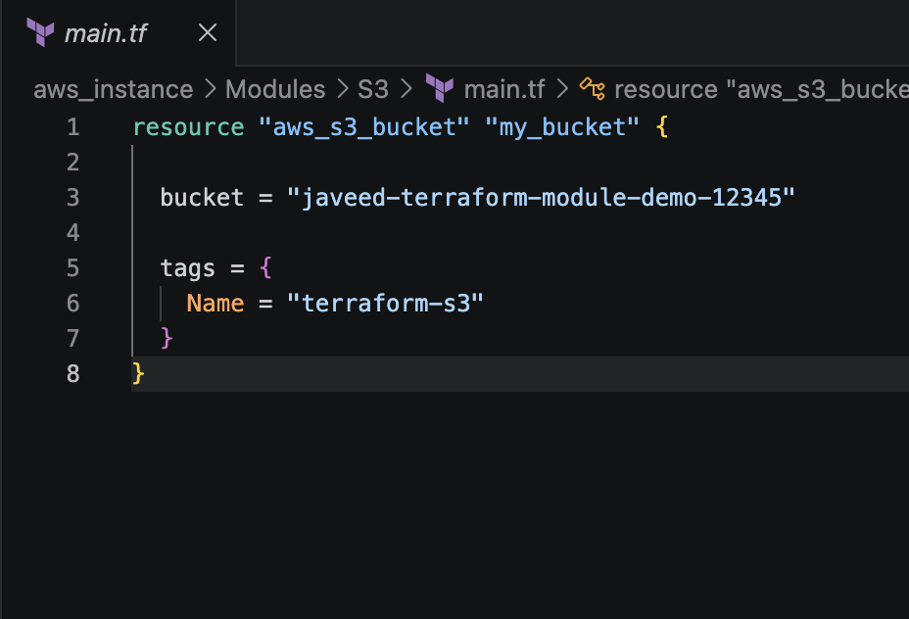
EC2 →main.tf
resource "aws_instance" "my_ec2" {

ami = "ami-0b6d9d3d33ba97d99"
instance_type = "t3.micro"
Subnet_id = “”
Associate_public_ip_address = true

tags = {
Name = "terraform-ec2"
}
}

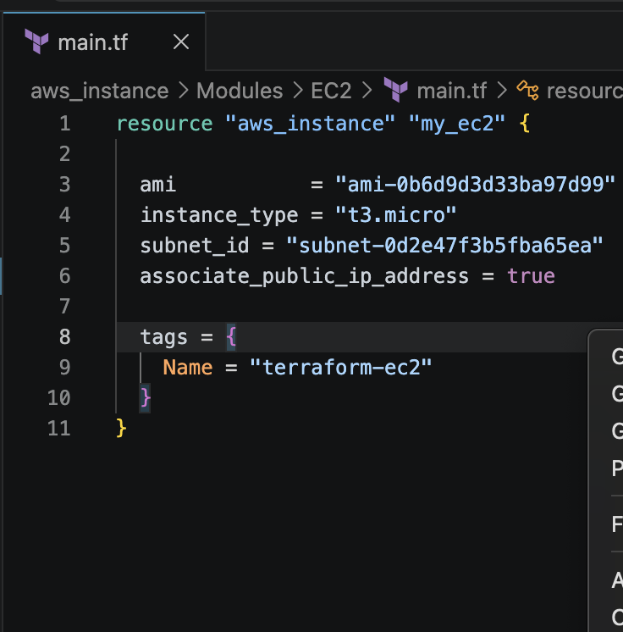
Now lets intialize terraform now
terraform init
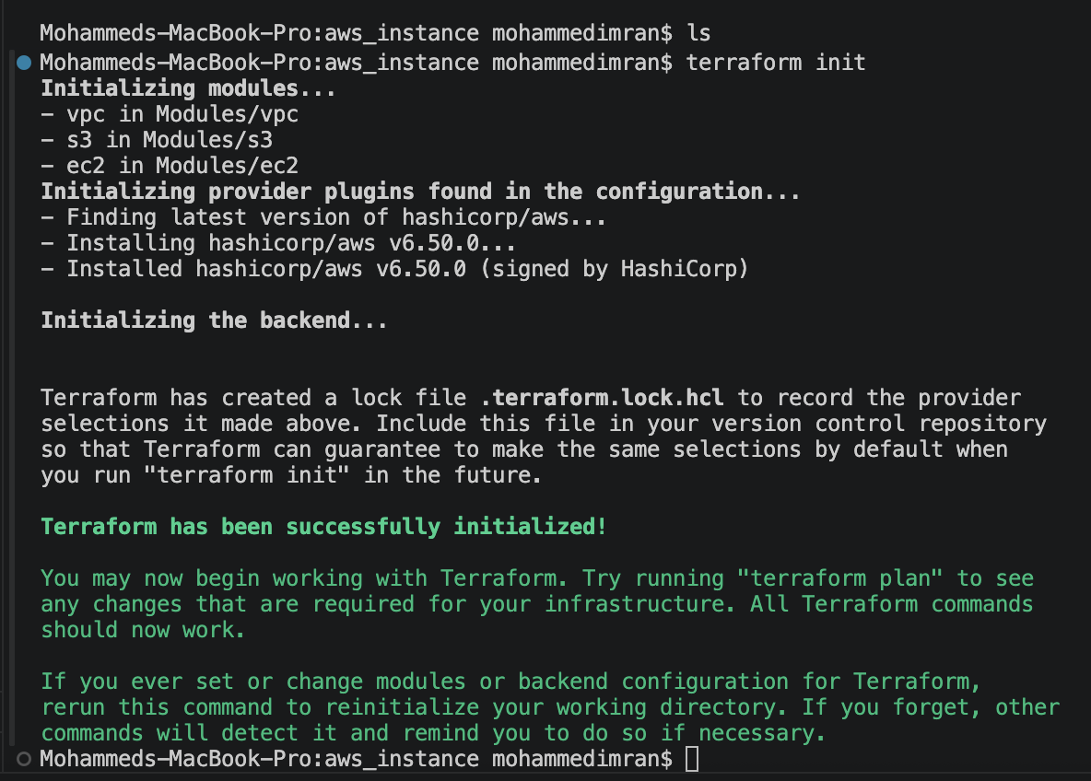
terraform plan ⇒ DRY RUN
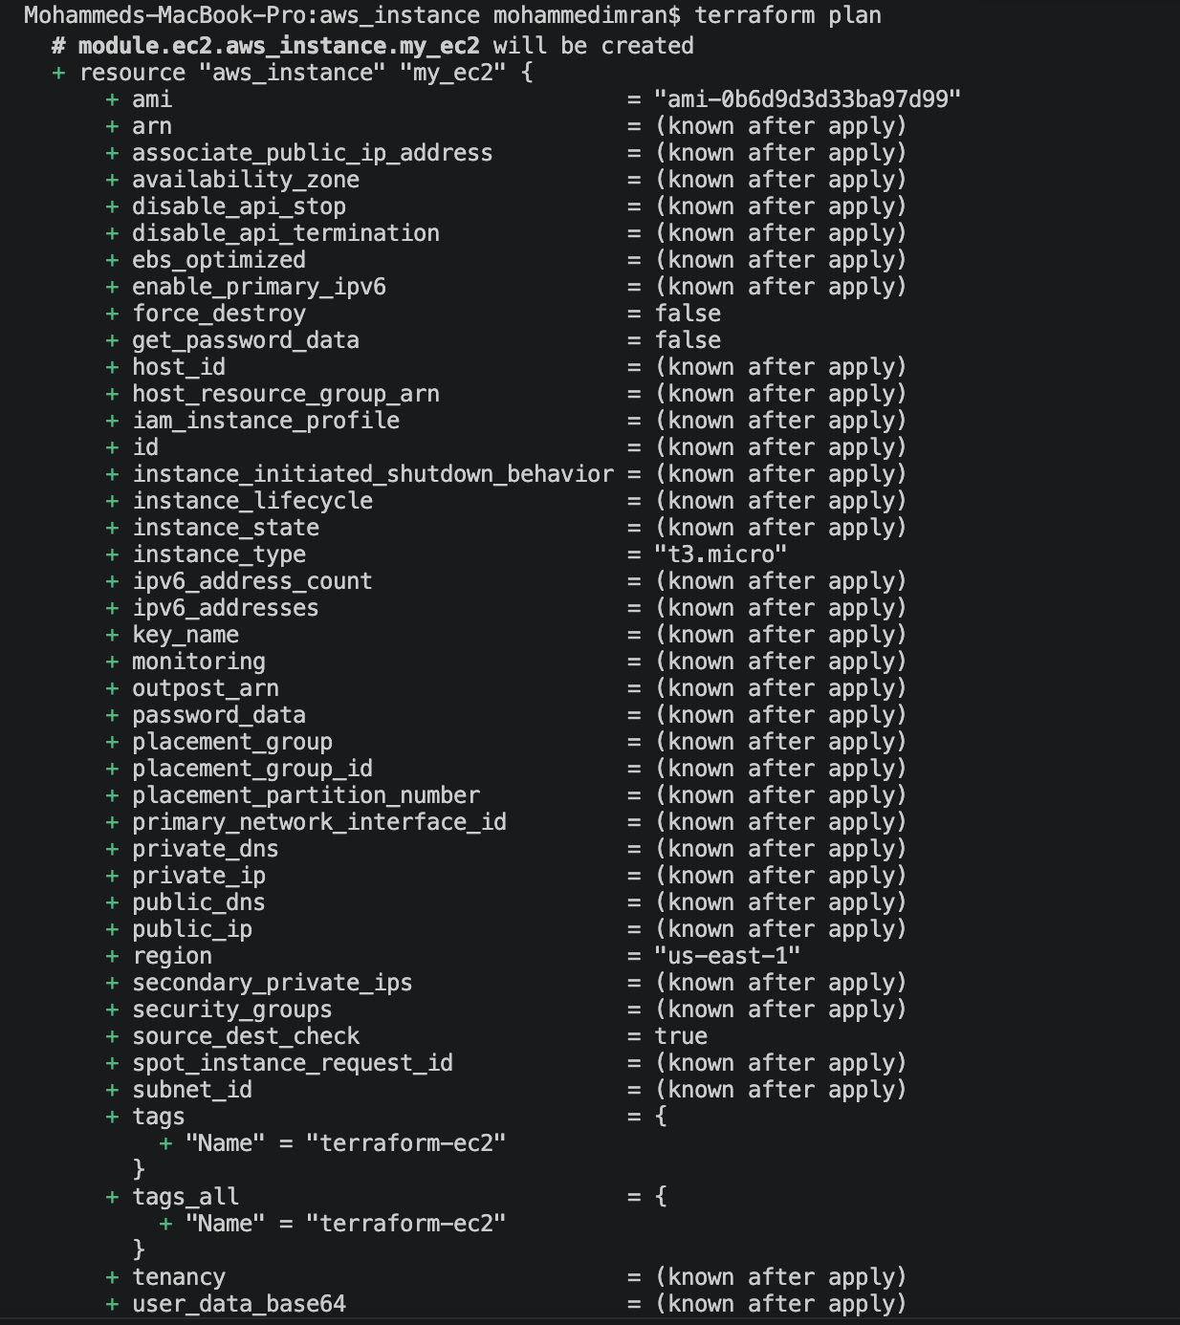
terraform validate
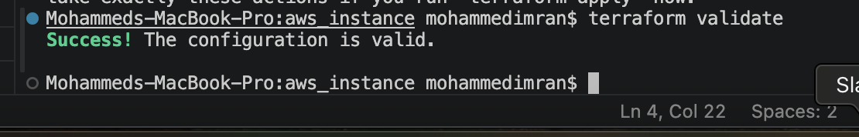

terraform apply
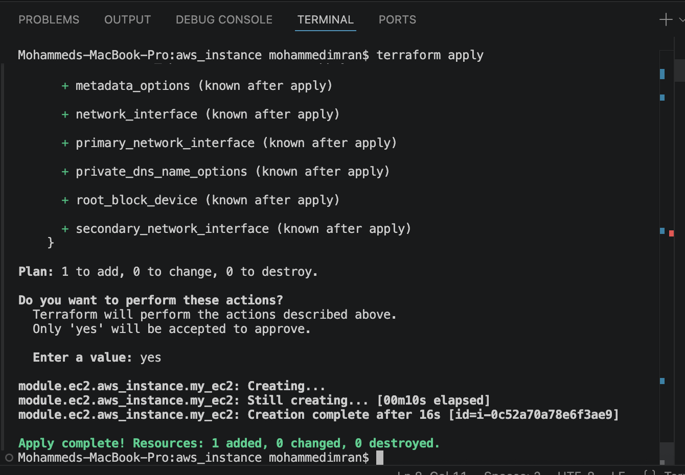
Lets check in AWS EC2 → if the instance has been created or not
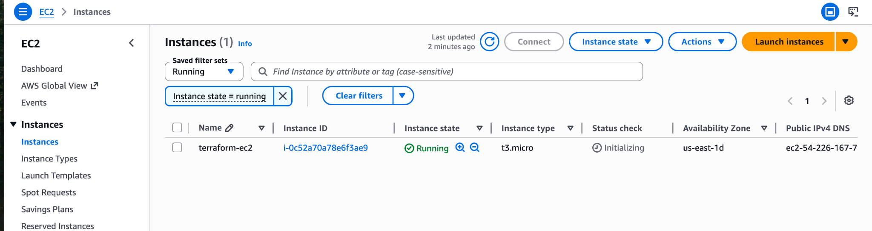

4). Provision EC2 for 3 different environments (Dev, Staging, and Prod) using Terraform workspaces.

First let's create a directory called terraform-workspace.
Now lets add a file called main.tf
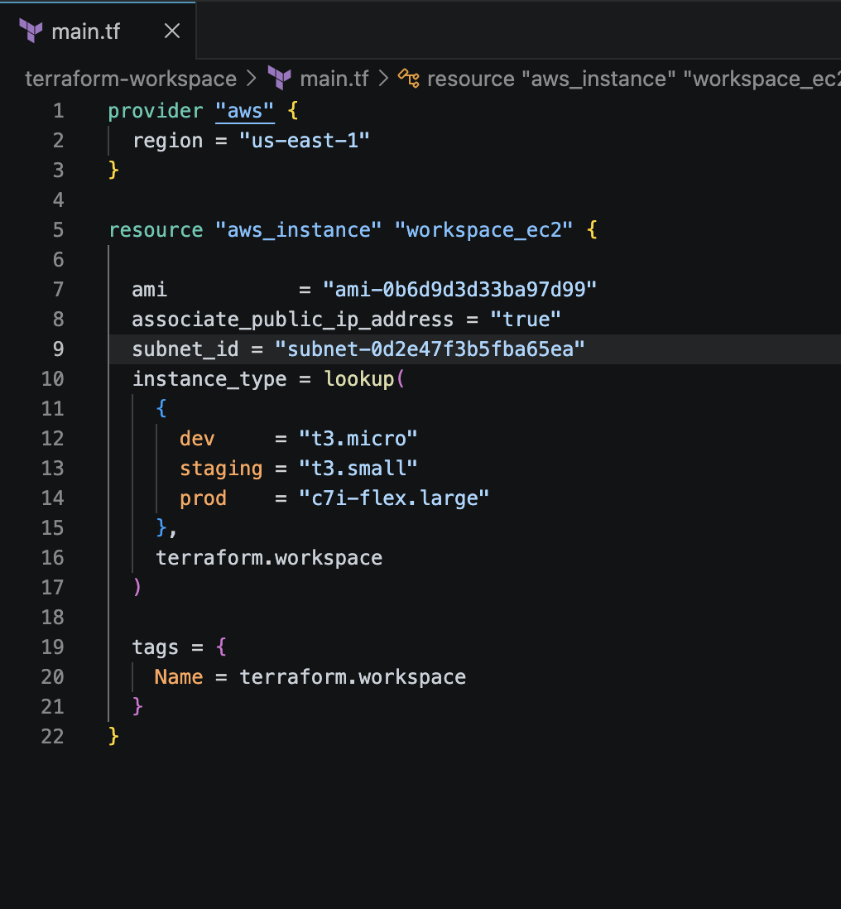

Lets do terraform init
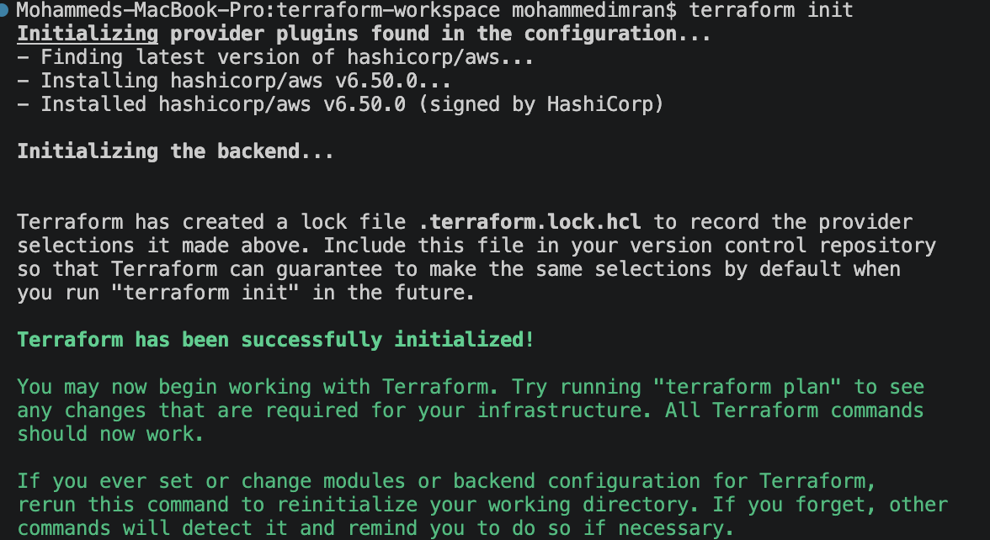
Now let's create a workspace. First lets check if we have any workspaces from before
terraform workspace list → to check the list of workspaces we have and * indicates in which workspace we are located.
terraform workspace new dev→ it creates a new workspace called dev
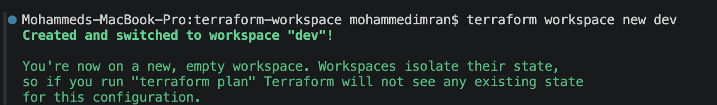
terraform workspace new stage→ it creates a new workspace called stage
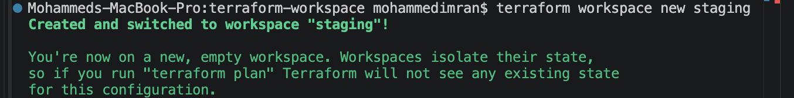
terraform workspace new prod→ it creates a new workspace called prod
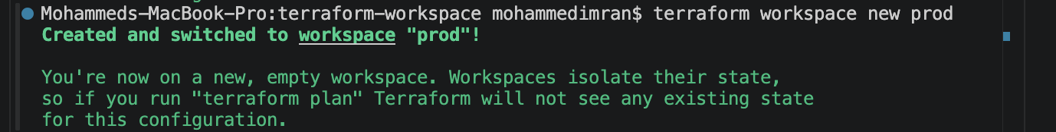
terraform workspace list → to check the list of workspaces we just created
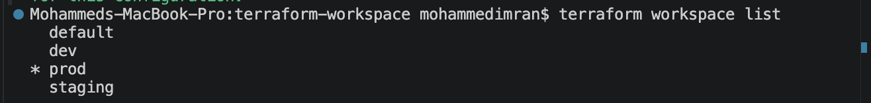
All our workspace get stored in a folder called terraform.tfstate.d
Lets create an ec2 instance by using the workspace we created. Fore that we need to be in the workspace we created for that we will be using the command
terraform workspace select dev

terraform apply
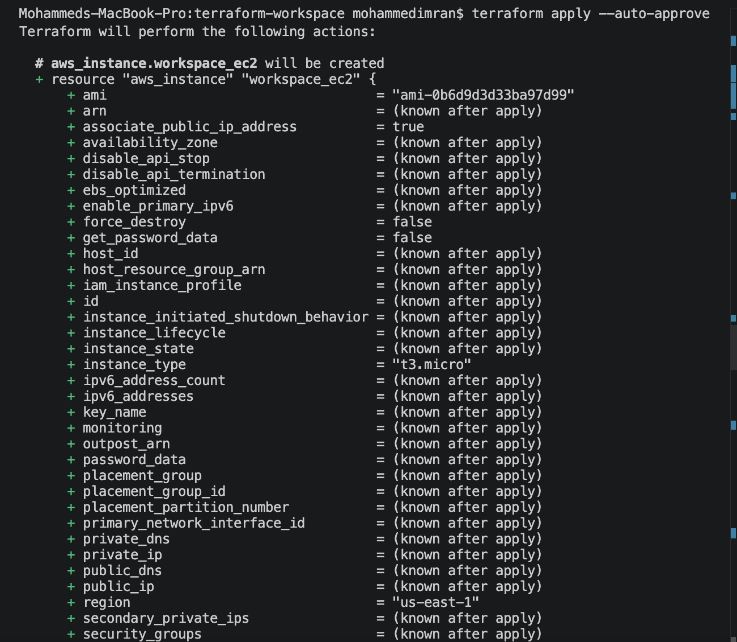

terraform workspace select staging
terraform apply

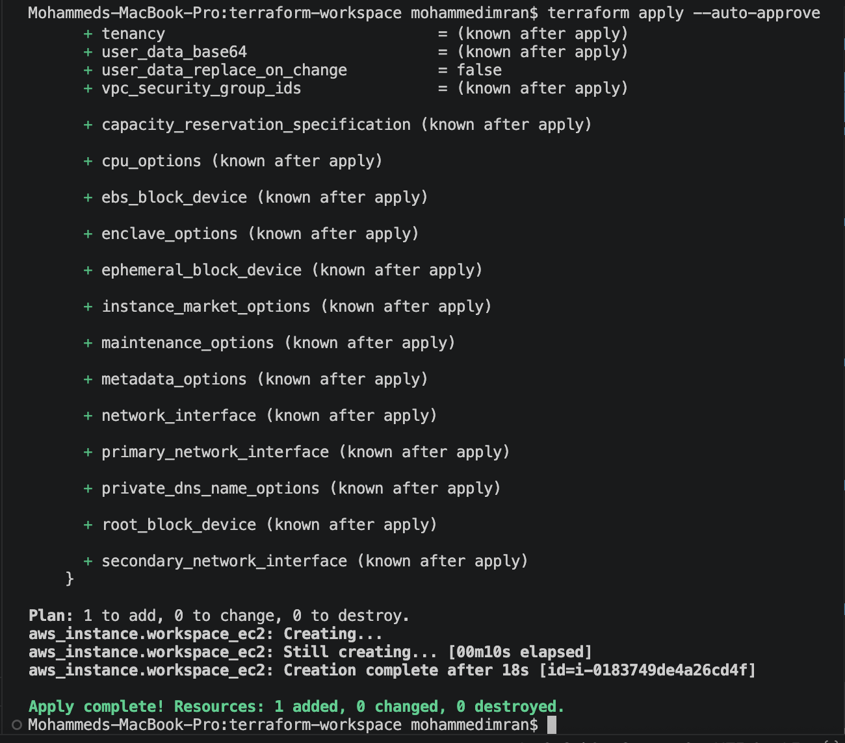

terraform workspace select prod
terraform apply


Lets check in AWS EC2 if the instances have been created or not
